MUIDS International Day Schedule
Wednesday May 18th, 2016
MUIDS will be celebrating out inaugural International Day on Wednesday May 18th. The festivities will center on food, cultural performances and fun with teachers and friends. We will be also welcoming special guests to our school to help bring an international focus and make the day memorable. Wednesday will be a free dress day, but students are encouraged to wear clothing that represents Thai culture or an International culture of their choice.

- Period 1 – 3: Classes as Normal
- 11:00 – 12:30: Preparation time - 10th and 11th grade students report to assigned rooms for costume preparation, or to ground floor for food preparation. Grade 12 students may report to cafeteria.

- 12:30 – 1:30: International Food Festival – 10th and 11th grade students will serve snacks from countries around the world. Habesha Restaurant will also be selling Ethiopian food and traditional coffee, and Mamma Mia’s Restaurant will be selling Italian meals. In addition the Cafeteria will be open as normal.

- 1:45 – 2:15: International Fashion and Culture Show – 10th and 11th Grade students will highlight the fashion and culture of their chosen country in an ‘International Runway’ competition.

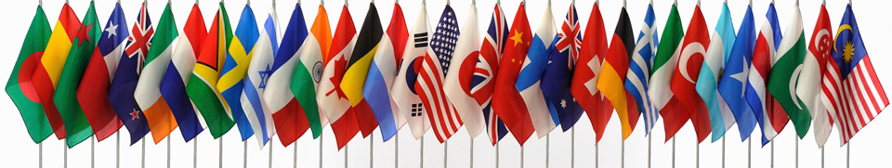
- 2:15 – 4:00 – Cultural Performances: Featuring Ethiopian Dance provided by Habesha Restaurant, Speakers from the Kingdom of the Netherlands Embassy and the Embassy of Sweden, Thai cultural performance, the Thai Folksong Club and more.

